
FinWise AI: Intelligent Loan Eligibility, Credit Analysis & Financial Advisory Platform

Project Description:
FinWise AI: Intelligent Loan Eligibility, Credit Analysis & Financial Advisory Platform is a web-based application designed to help users make informed financial decisions. The platform enables users to check loan eligibility based on salary, credit score, age, and existing EMI, analyze their credit score, calculate monthly EMI, and receive personalized financial guidance using the Google Gemini AI API. Built using HTML, CSS, JavaScript, and the Gemini API, the application provides an intuitive, responsive interface for users to access essential financial tools in one place. FinWise AI aims to simplify financial planning and promote better money management through AI-powered recommendations and interactive financial calculators.

Scenarios

Scenario 1:
A user earning ₹50,000 per month enters their salary, credit score, age, and existing EMI in the Loan Eligibility Checker. The system analyzes the inputs and instantly displays whether the user is eligible for a loan, along with the estimated eligible loan amount and the reasons for approval or rejection.
Scenario 2:
A user enters their credit score in the Credit Score Analyzer. The application categorizes the score as Poor, Good, or Excellent, explains the associated risk level, and provides personalized suggestions to improve the credit score.
Scenario 3:
A user wants financial guidance and asks, "I am 22 years old and earn ₹80,000 per month. How should I divide my salary between expenses, savings, and investments?" The AI Financial Advisor, powered by the Google Gemini API, generates personalized recommendations on budgeting, savings, SIPs, mutual funds, stocks, and emergency funds to help the user plan their finances effectively.

.

Technical Architecture:
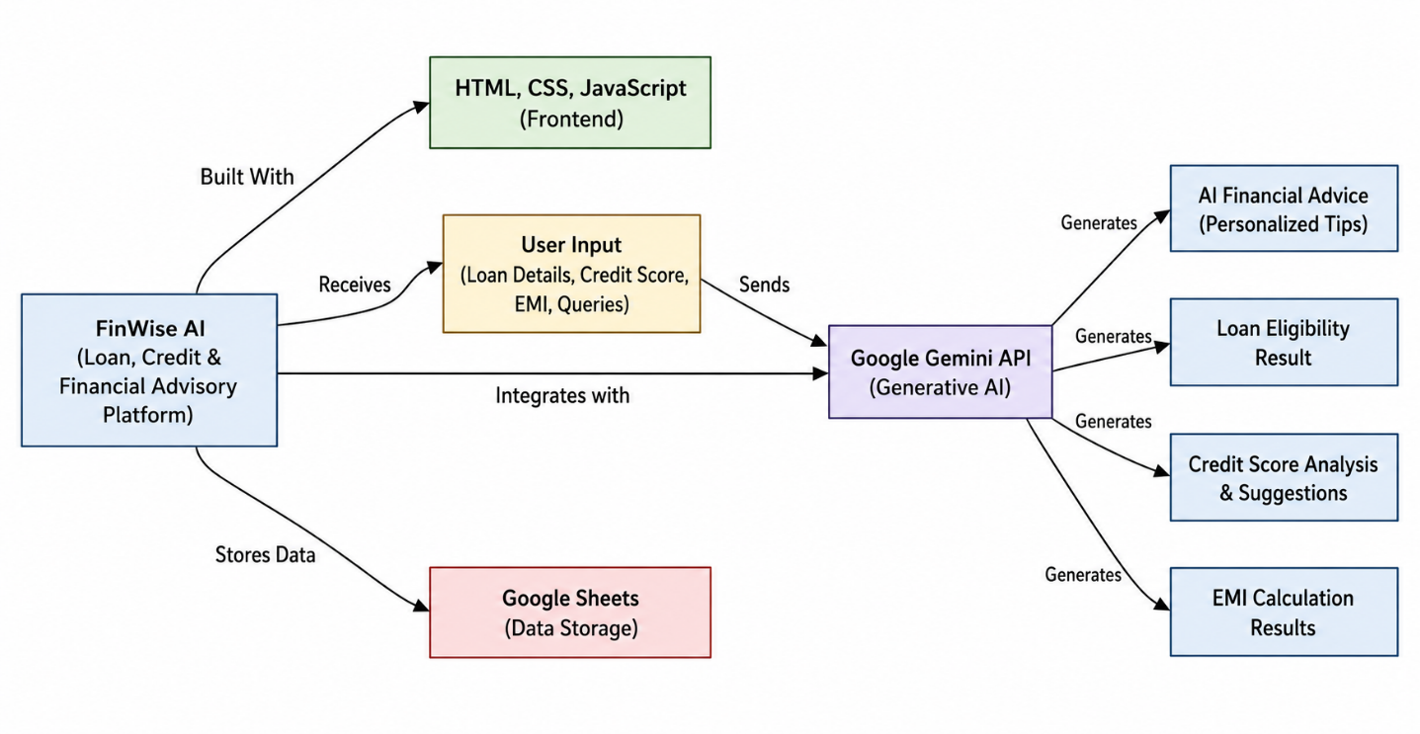
The technical architecture of FinWise AI illustrates the overall workflow of the system. User inputs are collected through a web interface developed using HTML, CSS, and JavaScript. The application processes loan eligibility, credit analysis, and EMI calculations, while financial queries are sent to the Google Gemini API to generate personalized financial advice. Loan-related data can also be stored in Google Sheets for record keeping, enabling a simple, responsive, and AI-powered financial advisory platform.
Pre-requisites
- HTML, CSS, and JavaScript Knowledge: W3Schools HTML/CSS/JavaScript Tutorials
- Google Gemini API Familiarity: Google AI Studio Documentation
- Google Apps Script & Google Sheets Integration: Google Apps Script Documentation
- VS Code Development Environment: Visual Studio Code Documentation
- Git & GitHub Basics: Git Documentation
- Web Browser for Testing (Google Chrome/Edge)

Project Workflow
Milestone 1: Project Planning & Architecture
- Activity 1.1: Define the project objectives and required financial modules.
- Activity 1.2: Generate a Google Gemini API key and configure it securely.
- Activity 1.3: Design the application architecture and user interface.
- Activity 1.4: Set up the development environment using VS Code.

Milestone 2: Core Functionalities Development
- Activity 2.1: Develop the Loan Eligibility Checker.
- Activity 2.2: Implement the Credit Score Analyzer.
- Activity 2.3: Build the EMI Calculator.
- Activity 2.4: Integrate Google Sheets for storing loan data (optional).

Milestone 3: AI Integration
- Activity 3.1: Integrate the Google Gemini API.
- Activity 3.2: Process user financial queries and display AI-generated financial advice.

Milestone 4: Frontend Development
- Activity 4.1: Design a responsive user interface using HTML, CSS, and JavaScript.
- Activity 4.2: Implement page navigation, form validation, and result display.

Milestone 5: Testing & Deployment
- Activity 5.1: Test all modules and validate user inputs.
- Activity 5.2: Deploy the project using GitHub Pages or Netlify.

Milestone 6: Documentation & Conclusion
- Activity 6.1: Prepare the project report, README, and presentation.
- Activity 6.2: Demonstrate the project and summarize the outcomes and future enhancements.

Milestone 1: Project Planning & Architecture
The first milestone focused on understanding the project requirements, identifying the core financial modules, designing the system architecture, and preparing the development environment. Proper planning helped in building a structured and efficient application.

Activity 1.1: Define the Project Objectives
The project objectives were finalized after identifying the essential financial services required by users. The application was planned to include four major modules: Loan Eligibility Checker, Credit Score Analyzer, EMI Calculator, and AI Financial Advisor. The main objective was to provide users with a simple and intelligent platform for financial planning and decision-making.
Activity 1.2: Generate Google Gemini API Key
A Google Gemini API key was generated using Google AI Studio and securely integrated into the project. The API was configured to process user financial queries and generate personalized financial advice, enhancing the application's intelligence and user experience.
Activity 1.3: Design the System Architecture
The application architecture was designed with a responsive frontend developed using HTML, CSS, and JavaScript. Financial calculations such as loan eligibility, credit analysis, and EMI computation were handled using JavaScript, while AI-based financial guidance was provided through the Google Gemini API. Google Sheets integration was also planned for optional data storage.
Activity 1.4: Set Up the Development Environment
The development environment was configured using Visual Studio Code as the code editor and Google Chrome for testing and debugging. The project was organized into separate HTML, CSS, and JavaScript files, and GitHub was used for version control and project management throughout the development process.
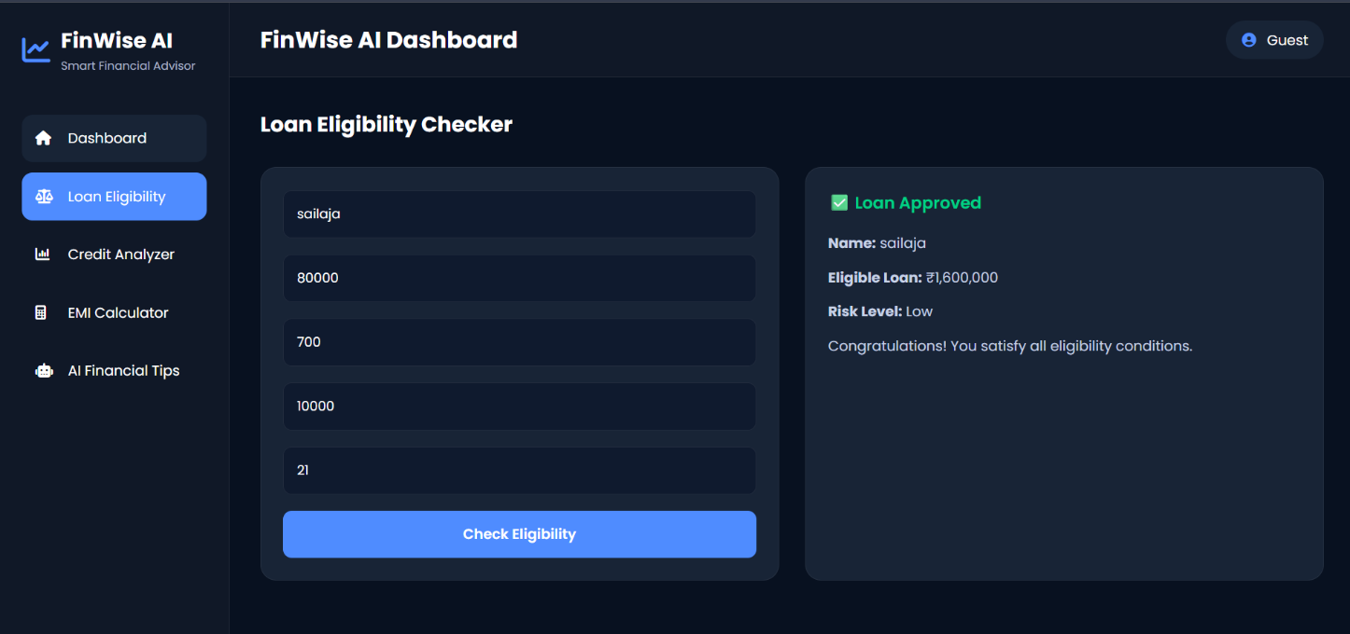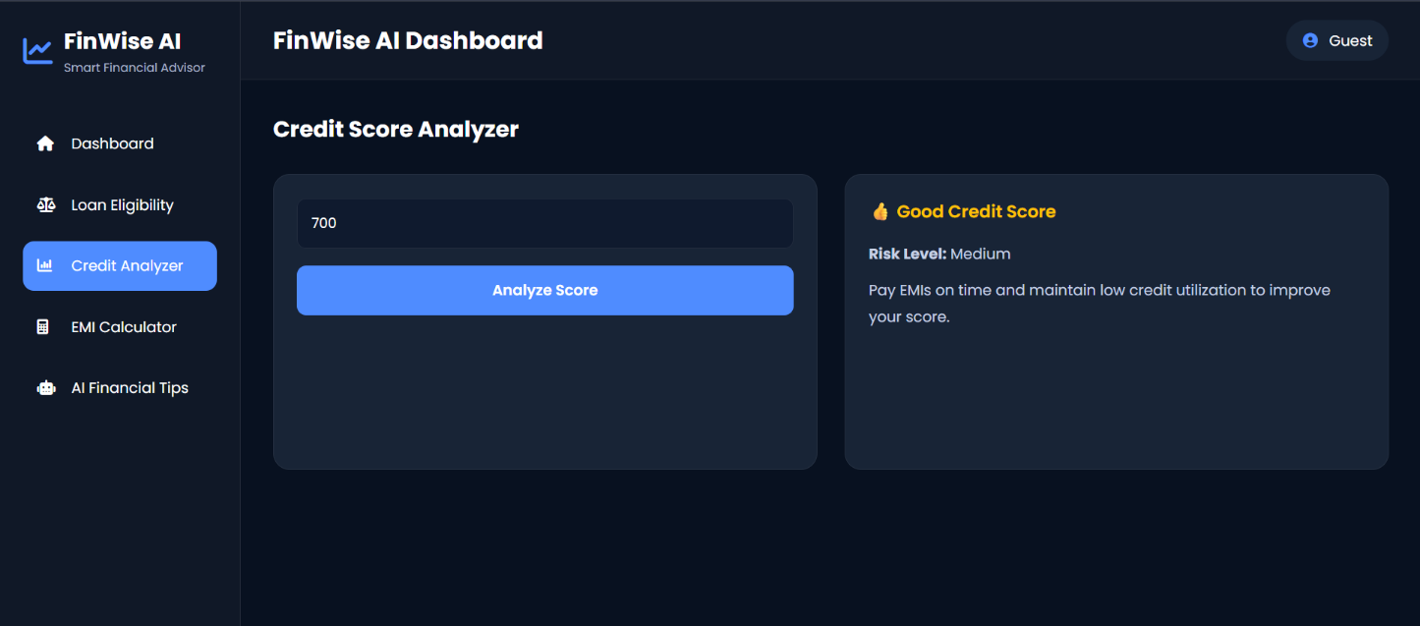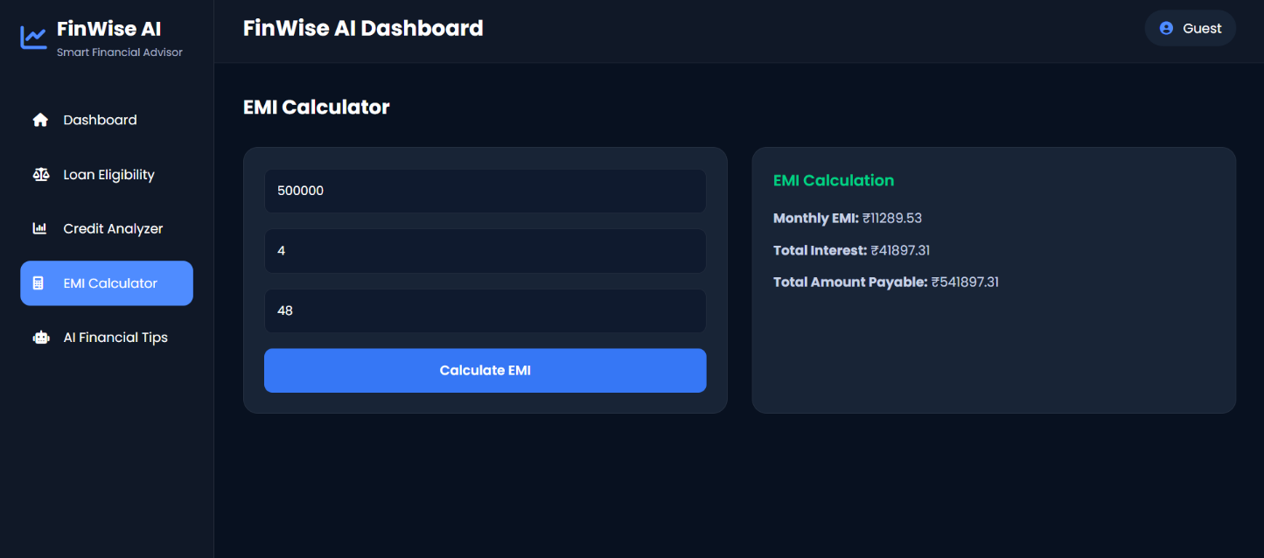

Milestone 2: Core Functionalities Development
The second milestone focused on developing the core functionalities of the application. Each financial module was implemented using JavaScript to provide accurate calculations, validations, and user-friendly outputs.

Activity 2.1: Develop Loan Eligibility Checker
The Loan Eligibility Checker was developed to evaluate whether a user qualifies for a loan based on inputs such as salary, age, credit score, and existing EMI. The module validates user inputs and displays the loan approval status along with the eligible loan amount or rejection reasons.

Activity 2.2: Implement Credit Score Analyzer
The Credit Score Analyzer was developed to assess the user's credit score. Based on the entered score, the system categorizes it as Poor, Good, or Excellent, displays the corresponding risk level, and provides suggestions to improve the credit score.

Activity 2.3: Build EMI Calculator
The EMI Calculator was implemented using the standard EMI formula. Users can enter the loan amount, interest rate, and loan tenure to calculate the monthly EMI, total interest payable, and total repayment amount instantly.

Activity 2.4: Integrate Data Storage
Google Sheets integration was added as an optional feature to store loan eligibility details using Google Apps Script. This allows user information and loan results to be saved for future reference and analysis.
This milestone ensured that all the primary financial modules were fully functional and ready for integration with the AI-based financial advisor.

Milestone 3: AI Integration

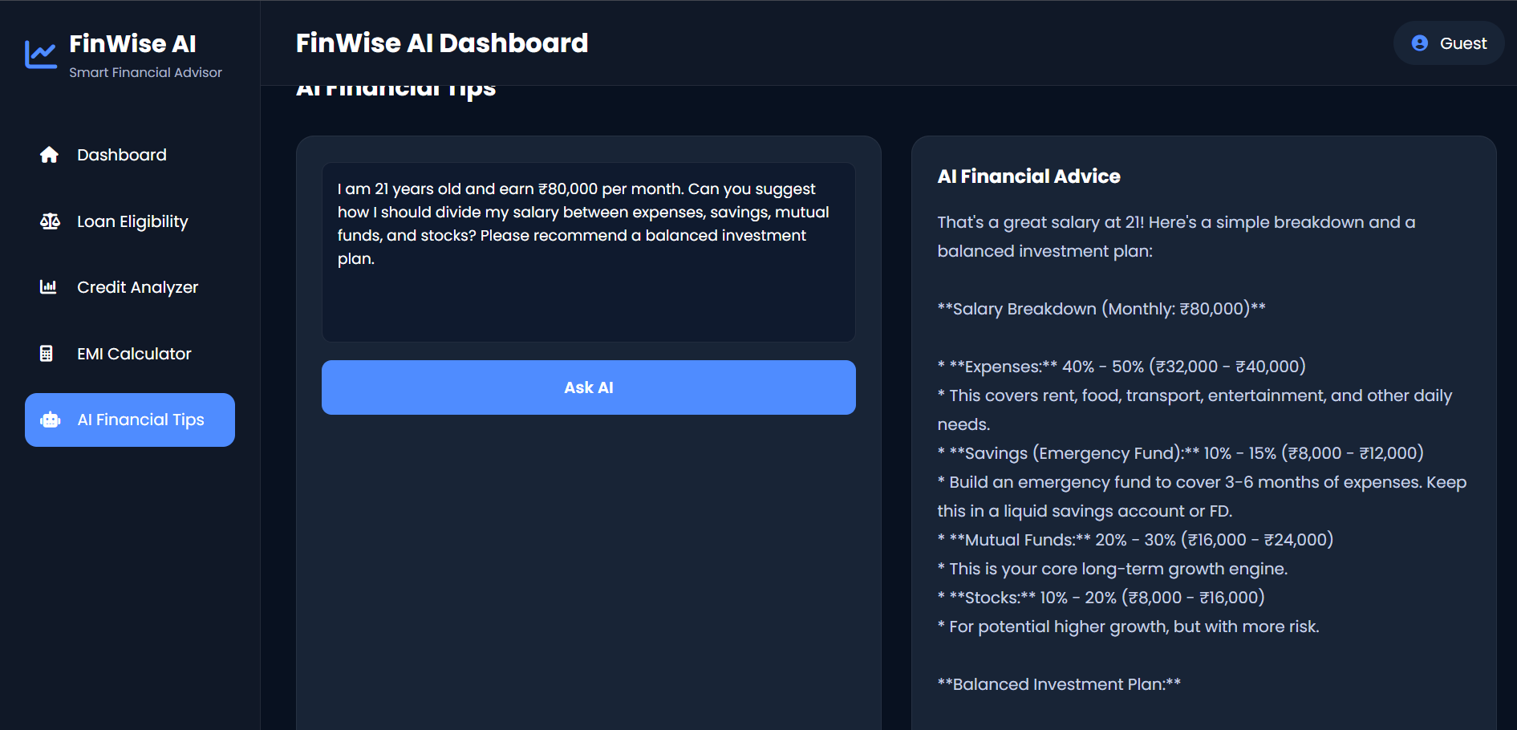
The third milestone focused on integrating the Google Gemini API to provide intelligent and personalized financial advice. This feature enhances the application by allowing users to ask finance-related questions and receive AI-generated responses.

Activity 3.1: Integrate Google Gemini API
A Google Gemini API key was configured in the application, and API requests were implemented using JavaScript. User queries entered through the Financial Advisor module are sent to the Gemini API, which processes the request and returns personalized financial recommendations. Proper error handling and response validation were also implemented to ensure reliable communication with the AI service.

Activity 3.2: Display AI-Based Financial Advice
The AI-generated responses are displayed in a user-friendly format within the application. The system also includes input validation and fallback messages to handle invalid queries or temporary API issues, ensuring a smooth user experience.
This milestone successfully integrated AI capabilities into the project, making FinWise AI an interactive and intelligent financial advisory platform.

Milestone 4: Frontend Development
The fourth milestone focused on designing and developing a responsive, user-friendly interface for the application. The frontend was built using HTML, CSS, and JavaScript to ensure smooth navigation and an intuitive user experience.
Activity 4.1: Design User Interface
A modern dashboard was created with a sidebar navigation menu and separate pages for Loan Eligibility Checker, Credit Score Analyzer, EMI Calculator, and AI Financial Advisor. Responsive layouts and consistent styling were implemented to provide a clean and interactive interface across different devices.
Activity 4.2: Implement User Interaction
JavaScript was used to handle page navigation, form validation, button actions, and dynamic result display. User inputs are processed instantly, and the calculated results or AI-generated financial advice are displayed without reloading the page, providing a smooth and interactive experience.
This milestone completed the frontend of the application, making FinWise AI easy to use, responsive, and visually appealing.

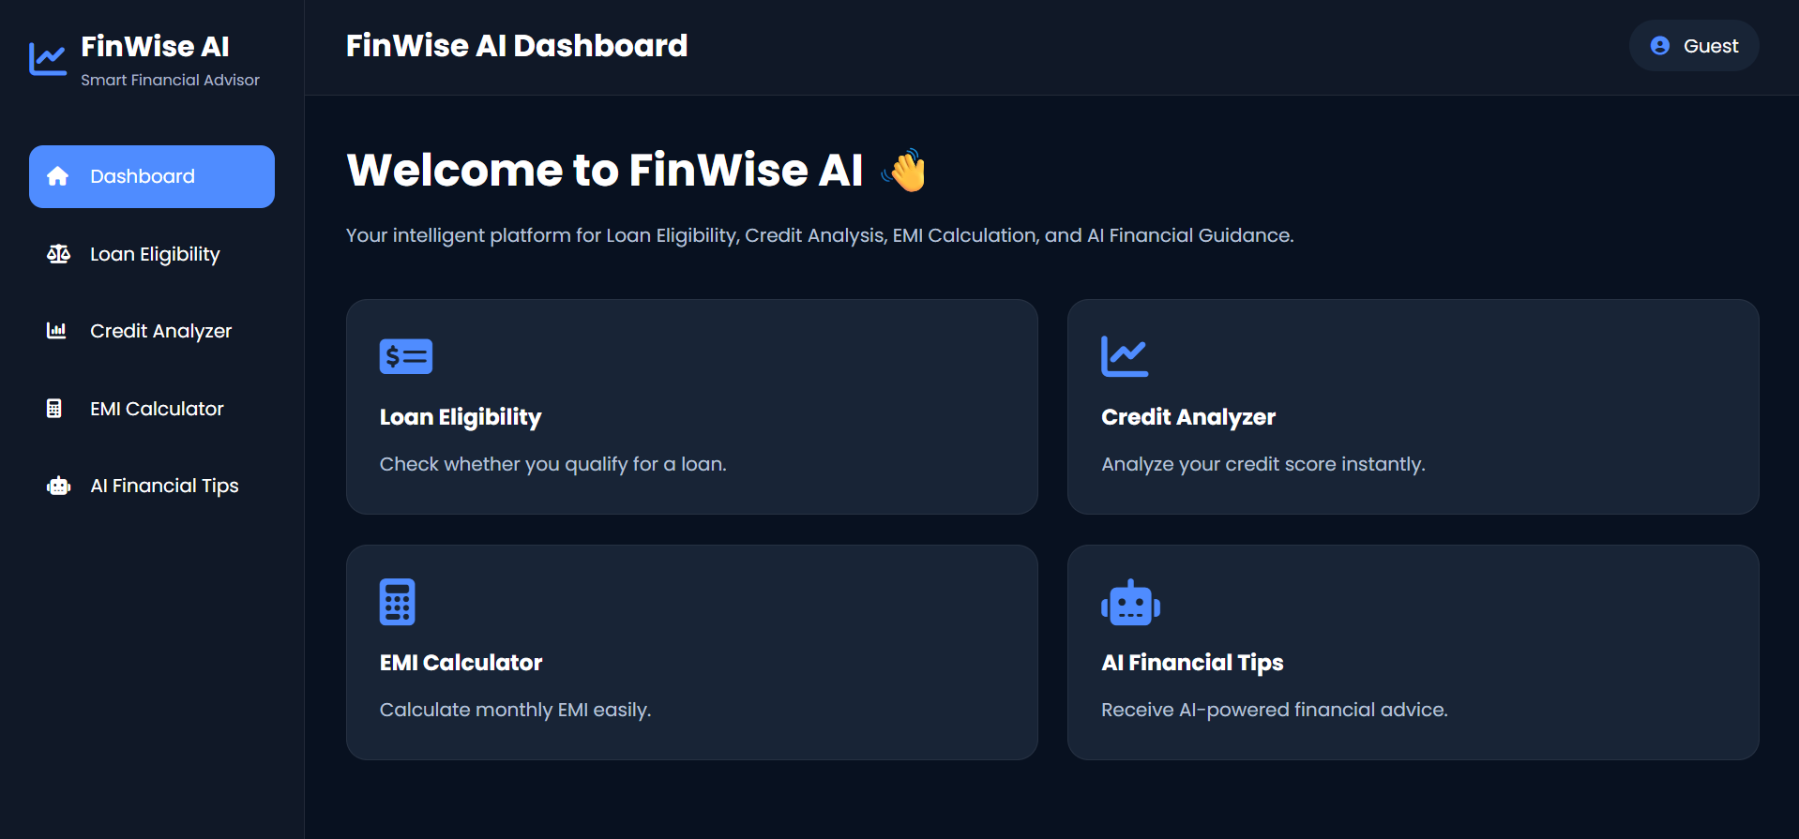
Milestone 5: Testing & Deployment
The fifth milestone focused on testing the application to ensure all modules functioned correctly and deploying the project for easy access.
Activity 5.1: Test the Application
All modules, including the Loan Eligibility Checker, Credit Score Analyzer, EMI Calculator, and AI Financial Advisor, were tested using different input values. Input validation, error handling, API responses, and overall functionality were verified to ensure accurate and reliable results.
Activity 5.2: Deploy the Project
After successful testing, the project was uploaded to GitHub for version control and source code management. The application was then deployed using GitHub Pages, making it accessible through a web browser for demonstration and evaluation.
This milestone ensured that the application was stable, fully functional, and ready for presentation and public access.

Conclusion
The FinWise AI: Intelligent Loan Eligibility, Credit Analysis & Financial Advisory Platform was successfully developed to provide users with a simple and efficient financial management solution. The application integrates essential financial tools such as Loan Eligibility Checker, Credit Score Analyzer, EMI Calculator, and an AI-powered Financial Advisor using the Google Gemini API. Built with HTML, CSS, JavaScript, and Gemini AI, the platform offers a responsive and user-friendly interface while delivering accurate financial calculations and personalized guidance. Overall, the project demonstrates how artificial intelligence can simplify financial decision-making and improve users' financial awareness through an interactive web application.

